

**PARENT REGISTRATION**

**HOW DO I SIGN UP?**1. Go to<https://carljunction-mo.finalforms.com/>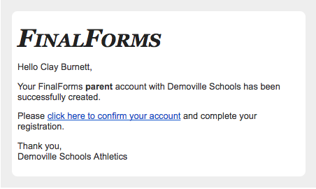

2. Click **NEW ACCOUNT** under the **PARENT** icon.   
  
3. Type your name, date of birth, and email, then click **REGISTER**.  
  
4. Check your email for a FinalForms email, and click **CONFIRM YOUR ACCOUNT** in the email text.  
  
*NOTE: You will receive an email within 2 minutes prompting you to confirm and complete your registration. If you do not receive an email, check your spam folder. If you still do not see the FinalForms email, please email* [*support@finalforms.com*](mailto:support@finalforms.com).

5. Create your new FinalForms password and click **CONFIRM ACCOUNT**.   
  
6. Click **REGISTER STUDENT** for your first child.



**REGISTERING A STUDENT**

**WHAT INFO WILL I NEED?**• Basic Medical History & Health Information **•**Insurance Company & Policy Number **•**Doctor & Dentist Contact Information **•**Hospital Preference



**HOW DO I REGISTER MY FIRST STUDENT?**

***\*\*\*IMPORTANT\*\*\**** *If you have followed the steps on the previous page, you may jump to step 3.*

1. Go to <https://carljunction-mo.finalforms.com/>



1. Click **New** under the **PARENT** icon.
2. Click **ADD STUDENT**

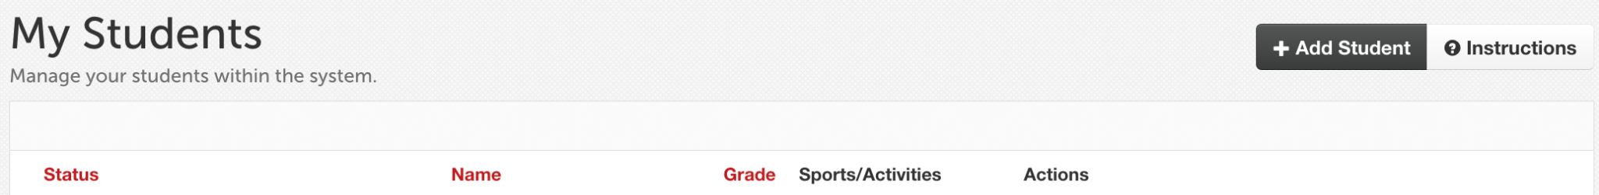

1. Type in the legal name and other basic information about the student. Click **CREATE STUDENT**.
2. If your student plans to participate in a sport, activity, or club*,* please click the checkbox for each.

Click **UPDATE** after making your selection.

***NOTE:*** *A selection can be changed at any time until the registration deadline.*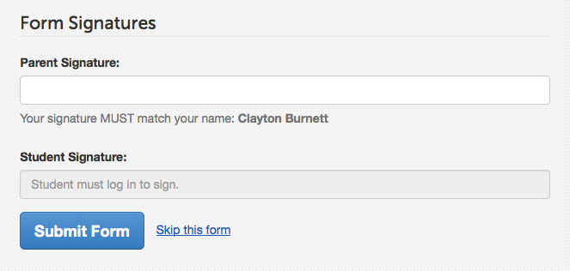

1. Complete each form and sign your   
   full name *(i.e., ‘John Smith’)* into the   
   **PARENT SIGNATURE** field at the bottom of   
   the page. After signing, click **SUBMIT FORM**   
   and move on to the following form.



1. You will see a *Forms Finished* message when all forms are complete.
2. ***\*\*\*IMPORTANT*** If required, an email will automatically be sent to the email address that you provided for your student, prompting him/her to sign the required student forms.***

**HOW DO I REGISTER ADDITIONAL STUDENTS?**

Click **MY STUDENTS**. You may repeat steps 3 through 7 for each additional student.

**HOW DO I UPDATE INFORMATION?**

Log in anytime and click **UPDATE FORMS** to update any student's information.